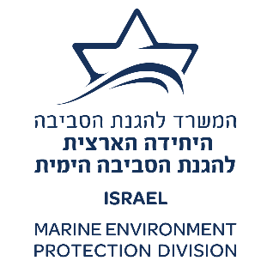
--------------------------------------------------------------------------------------------------------------------------------------------
SUB-REGIONAL MARINE OIL POLLUTION CONTINGENCY PLAN BETWEEN
CYPRUS, GREECE AND ISRAEL
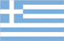
--------------------------------------------------------------------------------------------------------------------------------------------
Third Meeting of the National Operational Authorities responsible for the Implementation of the Sub-regional Marine Oil Pollution Contingency Plan between Cyprus, Greece and Israel | SCP CGI/MOA.3/10  Date: 10 November 2022

REPORT
OF THE THIRD MEETING FOR THE IMPLEMENTATION OF THE SUB-REGIONAL
MARINE OIL POLLUTION CONTINGENCY PLAN BETWEEN
CYPRUS, GREECE AND ISRAEL

Netanya, Israel, 22nd September 2022

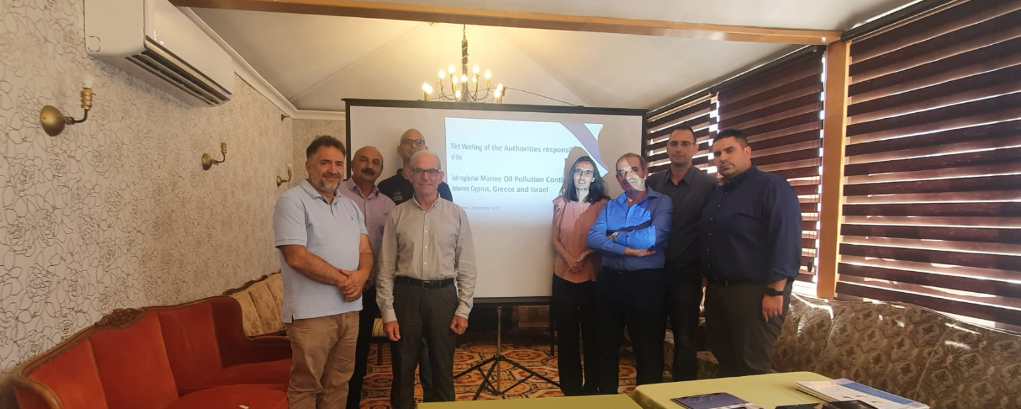

INTRODUCTION

- The third Meeting of the National Operational Authorities responsible for the implementation of the Sub-regional marine oil pollution contingency plan between Cyprus, Greece and Israel (the Meeting) was convened in Netanya, Israel the 22nd September 2022 within the framework of the Implementation Agreement between the Government of the Republic of Cyprus, and the Government of the Hellenic Republic and the Government of the State of Israel (the Agreement) on the Sub-regional Marine Oil Pollution Contingency Plan, (the Plan), signed at Nicosia, Cyprus on the 8th May 2018.

- The principal objectives of the Meeting were:

.1 to inform on the status of the ratification of the Implementation Agreement on the Plan;

.2 to work, where relevant, on the implementation of the Plan, prior to the entry into force of the Agreement and the Plan; and

.3 to discuss questions related to the implementation of the Plan, the organization of training courses and/or exercises, and other relevant matters.

- The meeting was hosted by the Marine Environment Protection Division (MEPD), Ministry of Environment, State of Israel and attended by delegations from Cyprus, Greece, Israel and by the representative of REMPEC. The complete list of participants is given in Annex I to the present Report.

AGENDA ITEM 1 OPENING OF THE MEETING

- The Meeting was opened by Mr. Fred Arzoine, Deputy Director at MEPD, on Thursday 22 September 2022, at 09.00 hours at the Seasons Boutique Hotel in the City of Netanya, Israel, on behalf of the host country.

- The representative of REMPEC, Mr. Malek Smaoui Programme Officer (OPRC), thanked MEPD for the organization of the Meeting. He recalled the agreed proposal of the second Meeting of the Competent National Authorities for the Preparation of the Plan (Nicosia, Cyprus 11-12 July 2017) to continue working on the implementation of the Plan prior to the formal entry into force of the Agreement and the Plan. He then outlined the objectives of the Meeting.

- Referring to the above agreed proposal, the representative of the Greek party, Captain Stylianos Markoulakis, informed the Meeting that Greece has ratified the Implementation Agreement in January 2022 and accordingly, the present meeting is henceforth organized while the Agreement is in force. The representative of REMPEC thanked Captain Markoulakis for this important information and requested notification of this ratification to REMPEC via the official channels.

- The Meeting decided that since the Agreement entered into force, the mention of preparatory will be deleted from the title of the present and future meetings of the National Operational Authorities (NOA) and the reference SCP CGI/PM (Preparatory Meeting) will be replaced by SCP CGI/MNOA.

- The representatives of the Cypriot, Greek and Israeli parties, respectively, introduced the members of their delegations and made comment on the Meeting objectives and suggestions to contribute to their achievement. The representative of the Cypriot party, Mr Stavros Ioannides, extended warm greetings form the Director of the Department of Fisheries and Marine Research, Mrs. Marina Argyrou, who regretfully could not make it due to a pressing schedule of principal commitments, as well as wishes for a successful meeting.

AGENDA ITEM 2 ORGANIZATION OF THE MEETING

2.1 Rules of Procedure

- The representative of REMPEC, referred to Article 2.5 (2) related to the Rules of Procedure for Meetings of National Operational Authorities, set out in the Annex 10 of the Plan, and revised by the 1st Preparatory Meeting, held in Larnaca, Cyprus on 6 December 2018, will apply mutatis mutandis to the deliberations of this Meeting.

2.2 Election of Officers

- The Meeting agreed that Mr. Fred Arzoine to act as Chairperson and according to Chapter 2.5 (5) of the Plan, and the Rule of procedure 3.4, the staff of the MEPD performs the secretarial duties for the Meeting.

2.3 Working Languages

- The working language of the Meeting was English.

AGENDA ITEM 3 ADOPTION OF THE AGENDA

- The Chairperson proposed that the Provisional Agenda, as set out in document SCP CGI/PM.3/3/1 and annotated in document SCP CGI/PM.3/3/2 as well as the timetable provided in document SCP CGI/PM.3/3/3 to carry out its work, be adopted.

- The Meeting adopted the Agenda reproduced in Annex II to the present report. The list of documents is set out in Annex III thereto.

AGENDA ITEM 4 STATUS OF RATIFICATION AND IMPLEMENTATION OF THE IMPLEMENTATION AGREEMENT ON THE PLAN

- The Chairperson invited the three delegations to inform the Meeting about the status of ratification by their respective countries of the Agreement and the Plan.

- The representative of the Israeli party recalled during the Meeting that, as already mentioned during the 2nd PM (Piraeus, Greece, October 2021), and detailed during the 3rd Meeting for the Preparation of the Plan (Nicosia, Cyprus, July 2017), the Agreement has already been ratified upon signature by the Minister of Environmental Protection of the State of Israel. The representative of the Cypriot party informed the Meeting as already in the 2nd PM (Piraeus, Greece, October 2021), the Agreement was ratified with the Law 4(III)/2001 (O.G. N. 4273/26-04-2021) of the Republic of Cyprus. The representative of the Greek party stated that the Agreement was ratified with the Law 4878/2022 (Governmental Gazette / 3A/17-01-2022) and that the Greek Ministry of Foreign Affairs notified the Republic of Cyprus, as the Depositary, on 1 February 2022.

- The representative of the Cypriot party added that upon receipt of the notification from the Greek Ministry of Foreign Affairs, the Cyprus Ministry of Foreign affairs has officially informed the parties of the Agreement, having addressed verbal notes to the Embassy of the State of Israel and the Embassy of the Hellenic Republic, specifying that the Implementation Agreement shall enter into force on the 2nd March 2022. Regarding REMPEC’s request reported in the above paragraph 6 of the present report, Cyprus will examine REMPEC representative’s claim for not having received notification about the Greek ratification.

- The Meeting took note of this information and welcomed the entry into force of the Implementation Agreement on the 2nd March 2022.

AGENDA ITEM 5 REVIEW AND UPDATE OF THE ANNEXES TO THE PLAN

- The Chairperson reminded that according to 6.6 of the Plan the revision of the Plan and its Annexes is the responsibility of the Competent National Governmental Authorities designated in Article 2.2.a), except the following Annexes 1, 2, 3, 4 and 5 which are the responsibility of the Competent NOA designated in Article 2.2.b):

- Annex 1: Directory of competent national authorities, contact points, emergency response centres, national on-scene commanders and other relevant addresses.

- Annex 2: Communications with REMPEC.

- Annex 3: National contingency plans (or relevant parts thereof).

- Annex 4: Directory of response personnel and inventory of response equipment, products and other means which each party might offer as assistance in case of the activation of the plan.

- Annex 5: Communications system.

- The Chairperson referred to paragraph 9 of Chapter 6.6 of the Plan stating that the Competent NOA of each Party, shall immediately circulate any such update(s) to the other Parties and to REMPEC. Such updates shall not require approval or ratification by the Parties in accordance with their relevant national procedures.

- The Chairperson reminded than the type of update by Annex as stated in paragraph 1 of Chapter 6.6:

- updating the information concerning names, titles and contact details (including postal addresses, telephone, fax and telex numbers, radio channels and frequencies, working hours) appearing in Annexes 1, 2 and 5;

- updating the information on the NCPs appearing in Annex 3; and

- updating the information on response resources appearing in Annex 4.

- At the invitation of the Chairperson, the representative of the Parties updated the Meeting about changes made to Annexes 1, 3, 4, and 5 taking into consideration the decisions laid down in paragraphs 25, 27, 28, 29 of the report of the 2nd PM. The representative of REMPEC also updated the Meeting with the changes on Annex 2, and on the hyperlink to the latest edition 2019, of the IOPC Funds “Claims Manual” in accordance with the paragraphs 26 and 30 of the report of the 2nd PM.

- The Chairperson invited REMPEC to inform the Meeting about achievements and proposals to facilitate and assist in the implementation of the Plan.

- The representative of REMPEC presented the new meeting working document SCP CGI/PM.5/3 submitted to the present Meeting under this Agenda item 5. He stated that this Document gathers the last version of the Annexes provided by the three Parties to Cyprus and submitted by Cyprus to REMPEC in accordance with the paragraph 23 of the report of the 2nd PM. It was initiated after experiencing confusion of different versions and aimed at ensuring that annexes in hand are effectively reflected in the latest versions.

- The meeting thanked REMPEC for this initiative and agreed on maintaining the proposed document among the set of the working documents of the forthcoming Meetings of NOA.

- With regard to the request of the 2nd PM for the creation of a section in REMPEC’s website where the Plan and documents of the Meetings for its implementation are uploaded, the representative of REMPEC informed the Meeting of the creation of the webpage, comprising the documents of the Plan's preparatory phase, the Plan and Agreement final version and the documents of the NOA 1st and 2nd meetings. Credentials to access the webpage were shared with the representatives of the three Parties. He requested the representatives of the Parties to advise on the extent of access to this webpage to other users and to comment on its the use during the test period.

- The Meeting welcomed the SCP CGI Webpage, requested REMPEC to make it more user-friendly, and to explore ways enabling each country to update the Annexes on this webpage and to automatically send a notification for the other sides.

- Referring to the request for support in preparing a joint response exercise on 2023, the representative of REMPEC informed the Meeting that the Centre ensured funds within its Programme of Work and Budget (2022-2023) to engage a consultant with the task to prepare the scenario of the joint response exercise. The process for his recruitment being scheduled mid-2023. The representative of the Cypriot Party requested the Meeting to postpone the joint exercise originally planned for 2023, in the view of the deployment of the three new anti-pollution vessels expected for 2024.

- The Meeting took note of the information provided by REMPEC about the ensured funds and the request of Cyprus to postpone the Exercise to 2024.

AGENDA ITEM 6 REVIEW AND ADOPTION OF A PROGRAM OF ACTIVITIES 2022-2023

- The Chairperson referred to the Sub-regional Workshop on Shoreline Clean Up Assessment Technique (SCAT) organised by REMPEC with the contribution the Marine Environment Protection Division (MEPD) during two days before the present Meeting. He informed that this event was the 3rd to be organised within the framework of the Plan and in accordance with the programme of Activities to support its implementation.

- The representative of REMPEC presented a short overview on the preparation, the delivery, the evaluation and closing remarks of the Workshop, the report will be disseminated to the three countries in due time.

- The Meeting endorsed the workshop recommendation for the development of an application for Shoreline Clean Up Assessment based on the related templates provided in the 2009 Mediterranean Oiled Shoreline Assessment Guidelines and the 2015 Oiled Shoreline Assessment Manual and invited REMPEC to submit it for examination and approval of the 15th Meeting of the Focal Points of REMPEC.

- The Chairperson invited the representatives of the Parties to present the activities which took place in their respective countries since the 2nd PM, as well as the development of their respective national preparedness and response systems, within a national, sub-regional and regional perspective. The representative of Greece informed the meeting about the National workshops organized, on July 2022 by REMPEC on RETOS (Readiness Evaluation Tool for Oil Spills) regarding the oil spill response planning and readiness assessment The representative of Israel informed the Meeting about the planned activity for the update of its NCP and accordingly the postponement to 2023 of the National Workshop on RETOS regarding the oil spill response planning and readiness assessment. The representative of Cyprus informed the meeting about the planned acquisition of 3 autonomous oil recovery vessels within the framework of the EU Recovery and Resilience Fund, scheduled to be delivered by 2024, to strengthen the National capacity and capability of corresponding to oil spill incidents in the East Mediterranean basin.

- The Chairperson invited the delegations to present any such proposals that they might have prepared focusing on the document SCP CGI/PM.1/7 ‘’Mid-term activities’’.

- The representative of REMPEC thanked the Chairperson for giving the opportunity to remind the Meeting with the initiative of REMPEC to establish a synergy between the SCP. The Meeting took note of the recommendation of the Study on the Synergy between the Sub-regional Agreements and the Contingency Plans of the western Mediterranean, encouraging the Parties of the existing agreements to take necessary steps towards the implementation of immediate opportunities for synergy by organising joint meetings of responsible national authorities and by sending mutual invitations, as observers, during exercises and aerial surveillance operations, to increase the level of mutual knowledge and understanding between national authorities and national response systems; and to ensure a constant operational dialogue;

- He informed the Meeting that REMPEC will announce the process of Synergy on May 2023 during a meeting to be organised and sponsored by REMPEC in the margin of ADRIASPILL CONF, Opatija Croatia and attended by the representative of each country member of a Sub-regional Agreement and Plan, in force.

- The meeting welcomed the initiative of REMPEC to organise a meeting with representatives from existing sub-regional agreements, in the margin of Adriatic Spill Conference 2023, to be held in Croatia on May 2023, and agreed to adhere in this initiative and to include “Synergies between sub-regional agreements and plans”, in the agenda of the forthcoming MOA and in accordance with the Rule of procedure No 9.

AGENDA ITEM 7 OTHER BUSINESS

- The Meeting was invited to consider any other issue put forward by national delegations.

- The Chairperson requested the Meeting to introduce and discuss any proposal of amendment to the Plan and its other annexes referred to in the above Paragraph 18. He then referred to the comment of the 2nd PM to reconsider the matter of flexibility regarding the frequency of Meetings matter in the near future, laid down in paragraph 8 of the report of the Meeting. The aim was to review the frequency of the periodic MOA from one year to at least every two years.

- The Meeting decided to review Annex 10 on Rules of Procedures of the NOA in the next meeting, regarding the possibility to hold ordinary meetings at least once every two years. Towards the next meeting, Cyprus and Greece will explore the legal aspects of changing Article 2.5 of the Plan.

AGENDA ITEM 8 DATE, PLACE AND DURATION OF THE NEXT MEETING

- The Meeting decided to hold the next meeting of the NOA of the Parties in the margins of the Adriatic Spill Conference in May 2023 in Croatia. The agenda of the Meeting, [that could be organised as ad hoc meeting, in accordance with the Rule of Procedure No 6], will focus on the exercise that will be held in 2024 [and to consider the use of the funds allocated to this activity in 2023 for its preparation through the organization of a Tabletop Exercise or training on the preparation of Real case Exercise].

AGENDA ITEM 9 SUMMARY RECORDS OF THE MEETING

- The Secretariat drafted a summary record of the Meeting for each agenda item main points of discussion, conclusions, decisions and recommendations.

- The Meeting instructed the Secretariat to proceed with the preparation and dissemination of the final version of the Meeting's Report, taking into consideration all concluding remarks made under the present Agenda in accordance with the Rule of procedure No 24.

AGENDA ITEM 10. CLOSURE OF THE MEETING

- The Meeting was closed by the Chairperson on Thursday, 22 September 2022, at 14.00.

ANNEX I

LIST OF PARTICIPANTS

First and Last Name | Company and Job Title | Country | E-mail address
Mr Stavros Ioannides | Department of Fisheries and Marine Research | Cyprus | sioannides@dfmr.moa.gov.cy
Mr Marinos Ioannou | Department of Fisheries and Marine Research | Cyprus | maioannou@dfmr.moa.gov.cy
Mr Themos Evriviades | Deputy Ministry of Shipping | Cyprus | tevriviades@dms.gov.cy
Mr Konstantinos Mangidas | Hellenic Coast Guard/Marine Environment Protection Directorate | Greece | maggidaskostas@hcg.gr
Capt Stylianos Markoulakis | Deputy Director of Marine Environment Protection Directorate of Hellenic Coast Guard | Greece | smarkoul@hcg.gr
Mr Fred Arzoine | Marine Environment Protection Division - Deputy Director | Israel | Freda@sviva.gov.il
Ms Tahel Yashfe | InternationalRelations Division, Ministry of Environmental Protection | Israel | TahelY@sviva.gov.il
Mr Malek Smaoui | REMPEC - Programme Officer (OPRC) - Organiser of the Workshop and Meeting | Malta | msmaoui@rempec.org

ANNEX II

AGENDA OF THE MEETING

1. Opening of the Meeting
2. Organization of the Meeting
3. Adoption of the Agenda
4. Status of ratification and implementation of the Implementation Agreement on the Plan
5. Review and update of the Annexes to the Plan
6. Review and adoption of a program of activities 2022-2023
7. Other business
8. Date, place, and the duration of the next Meeting
9. Summary records of the Meeting.
10. Closure of the Meeting

ANNEX III

LIST OF DOCUMENTS

Working Documents

SCP CGI/PM.3/3/1 Provisional agenda
SCP CGI/PM.3/3/2 Annotated agenda
SCPCGI/PM.3/3/3 Draft timetable
SCP CGI/PM 5 Annexes update

Reference Documents

REMPEC/CGI SCP/WG.3/10 Report of the 3rd Meeting of the Competent National Authorities for the Preparation of the Plan (Nicosia, Cyprus - 11-12 July 2017)

SCP CGI/PM.1/7 Mid-Term Activities within the Framework of the Sub-regional marine oil pollution contingency plan between Cyprus, Greece and Israel during 2018–2019 Biennium or at a later stage (Long-Term)

SCP CGI/PM.1/10 Report of the 1st Preparatory Meeting (Larnaca, Cyprus - 6 December 2018)

SCP CGI/PM.2/9 Report the 2nd Preparatory Meeting (Piraeus, Greece - 7 October 2021)

REMPEC/WG.51/INF.4 Study on the Synergy between the Sub-regional Agreements and the Contingency Plans of the western Mediterranean

Information Document

Information to Participants Date –Venue –Registration –Documentation –Accommodation DSA –Travel –Visa –Contact Persons
PHOTOS

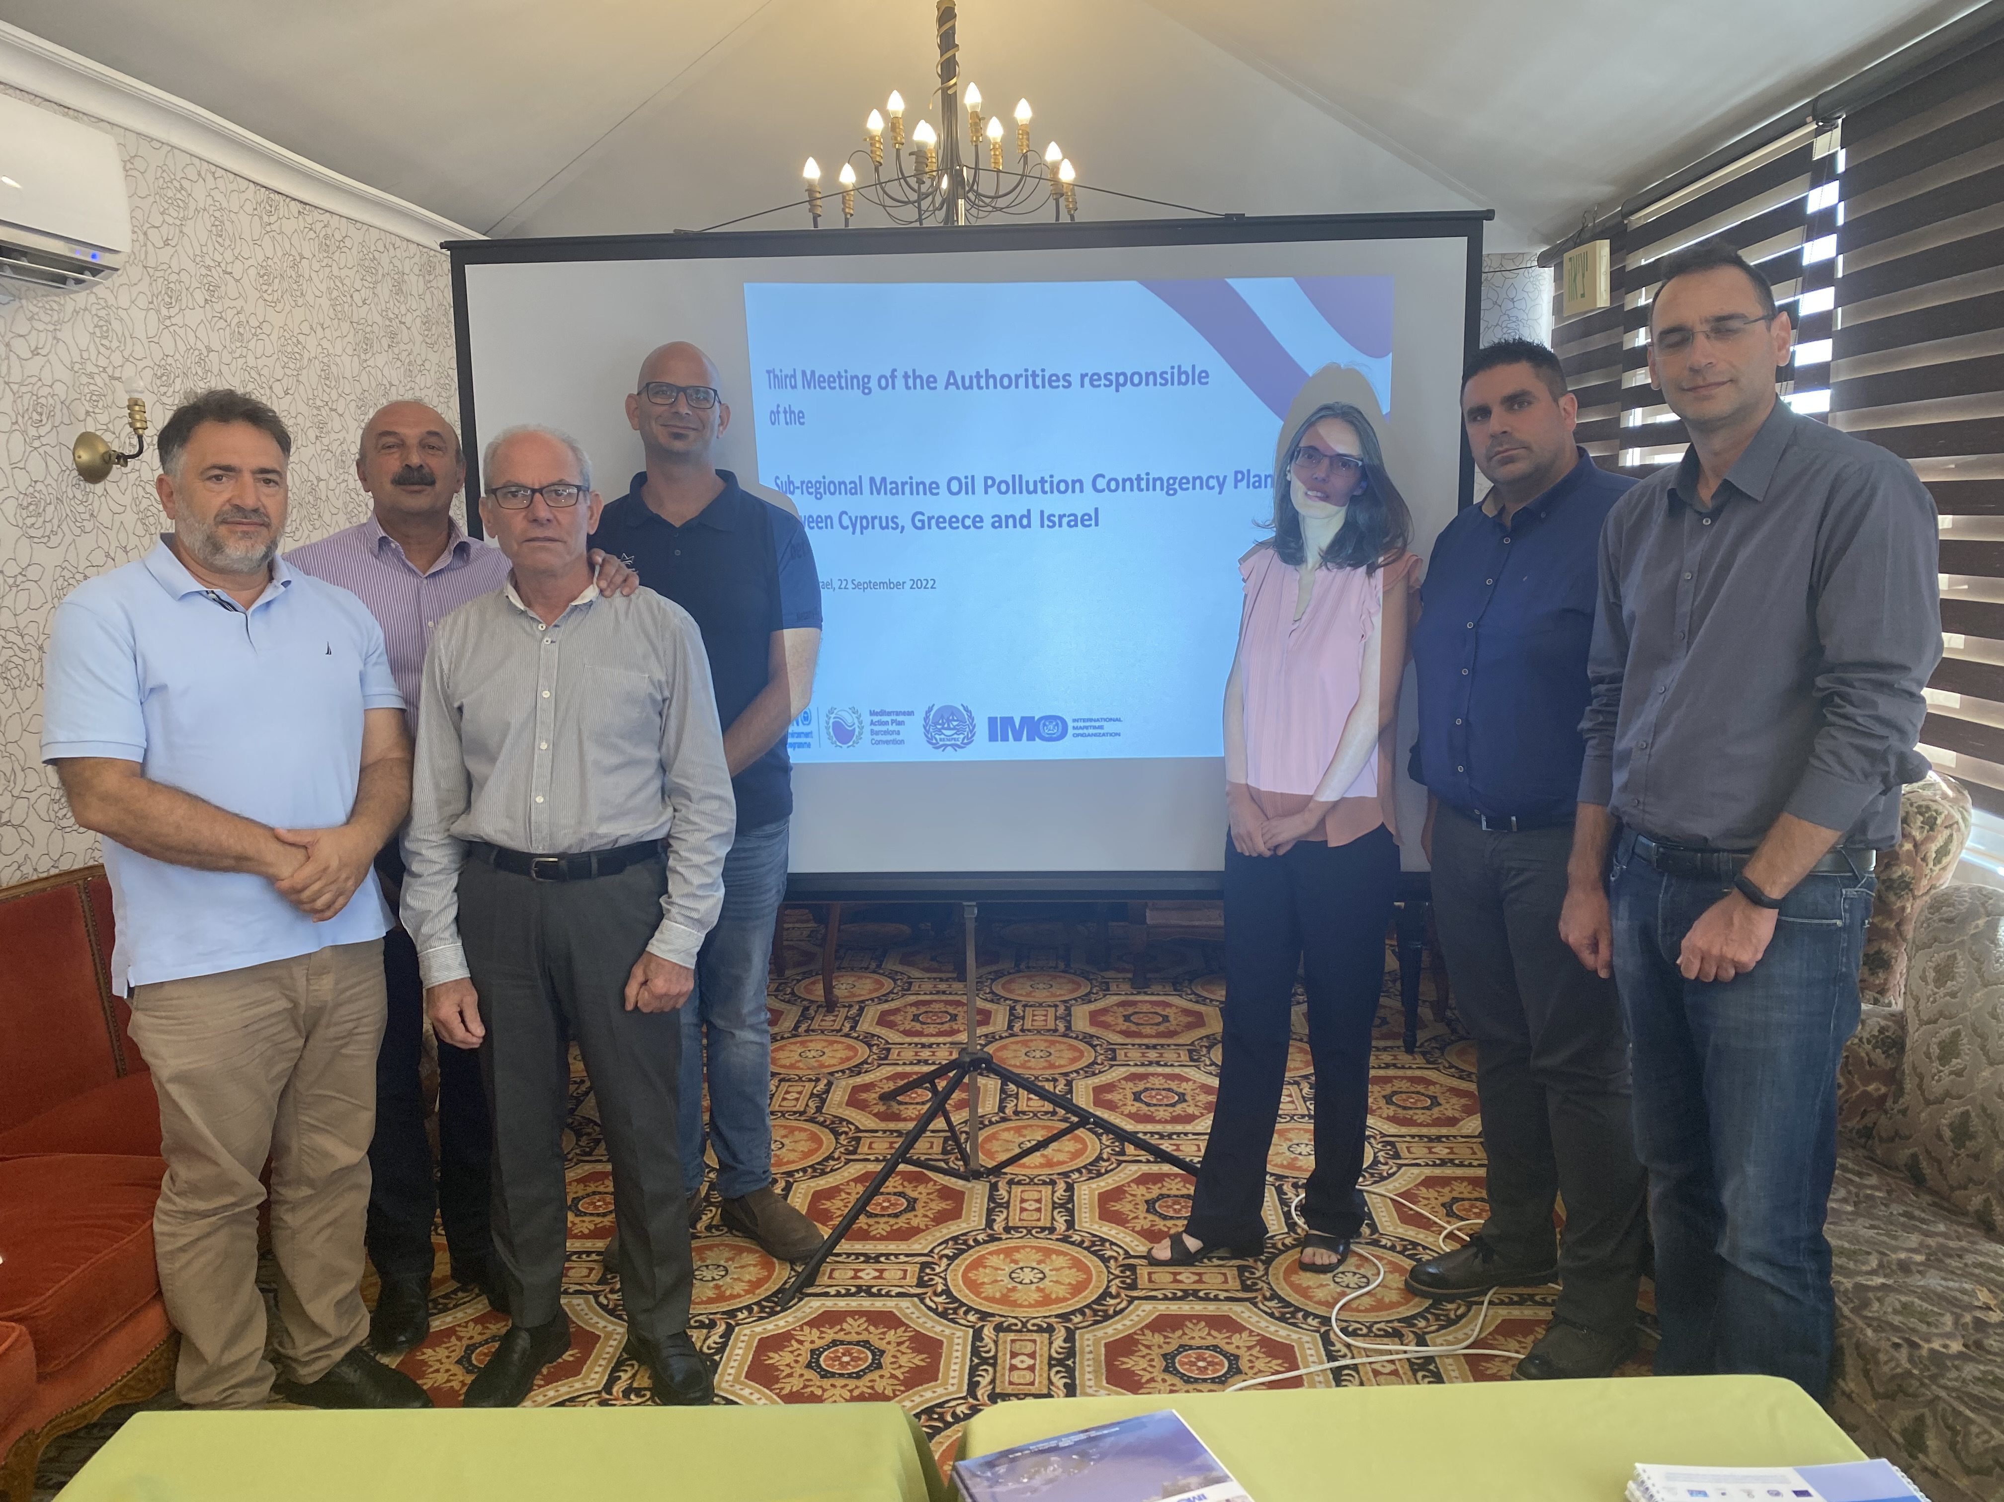
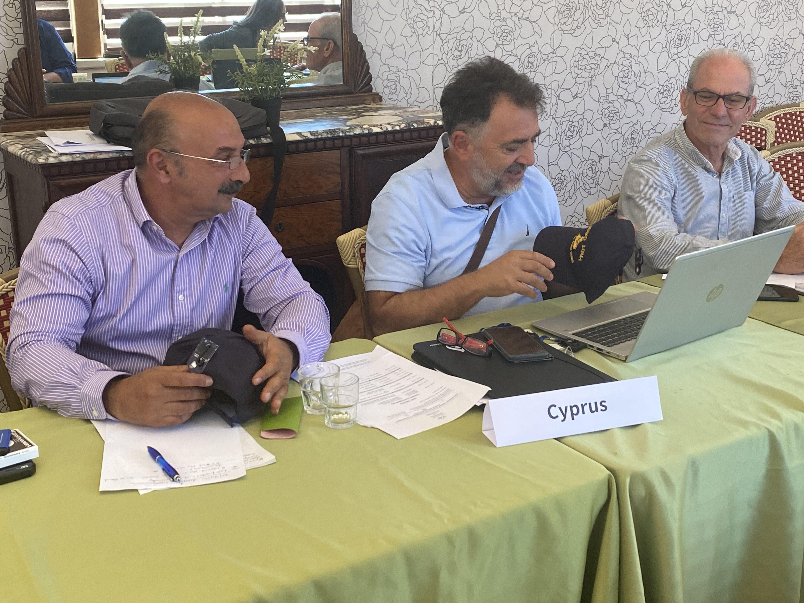 | 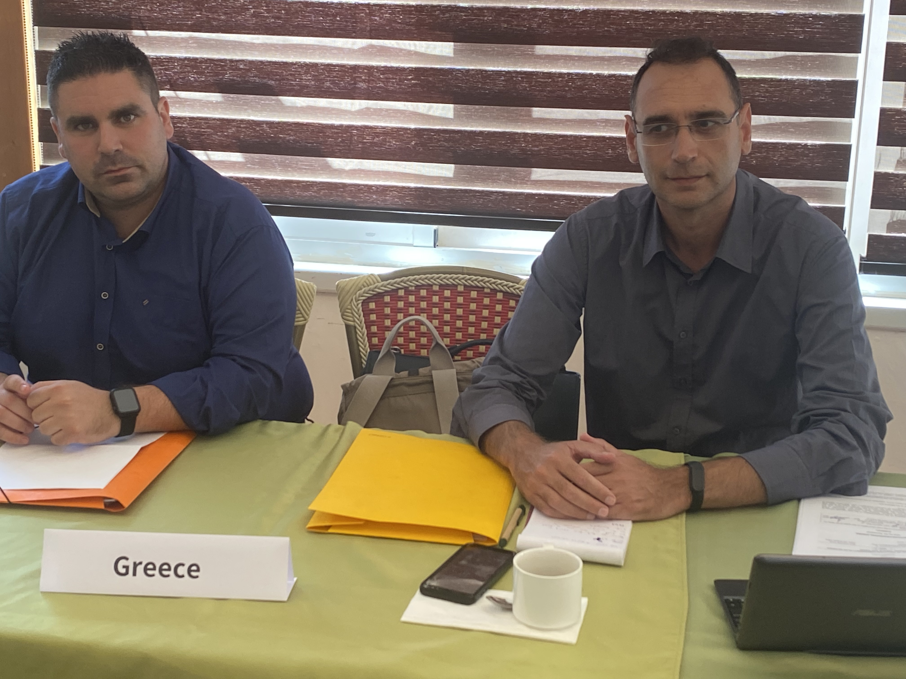
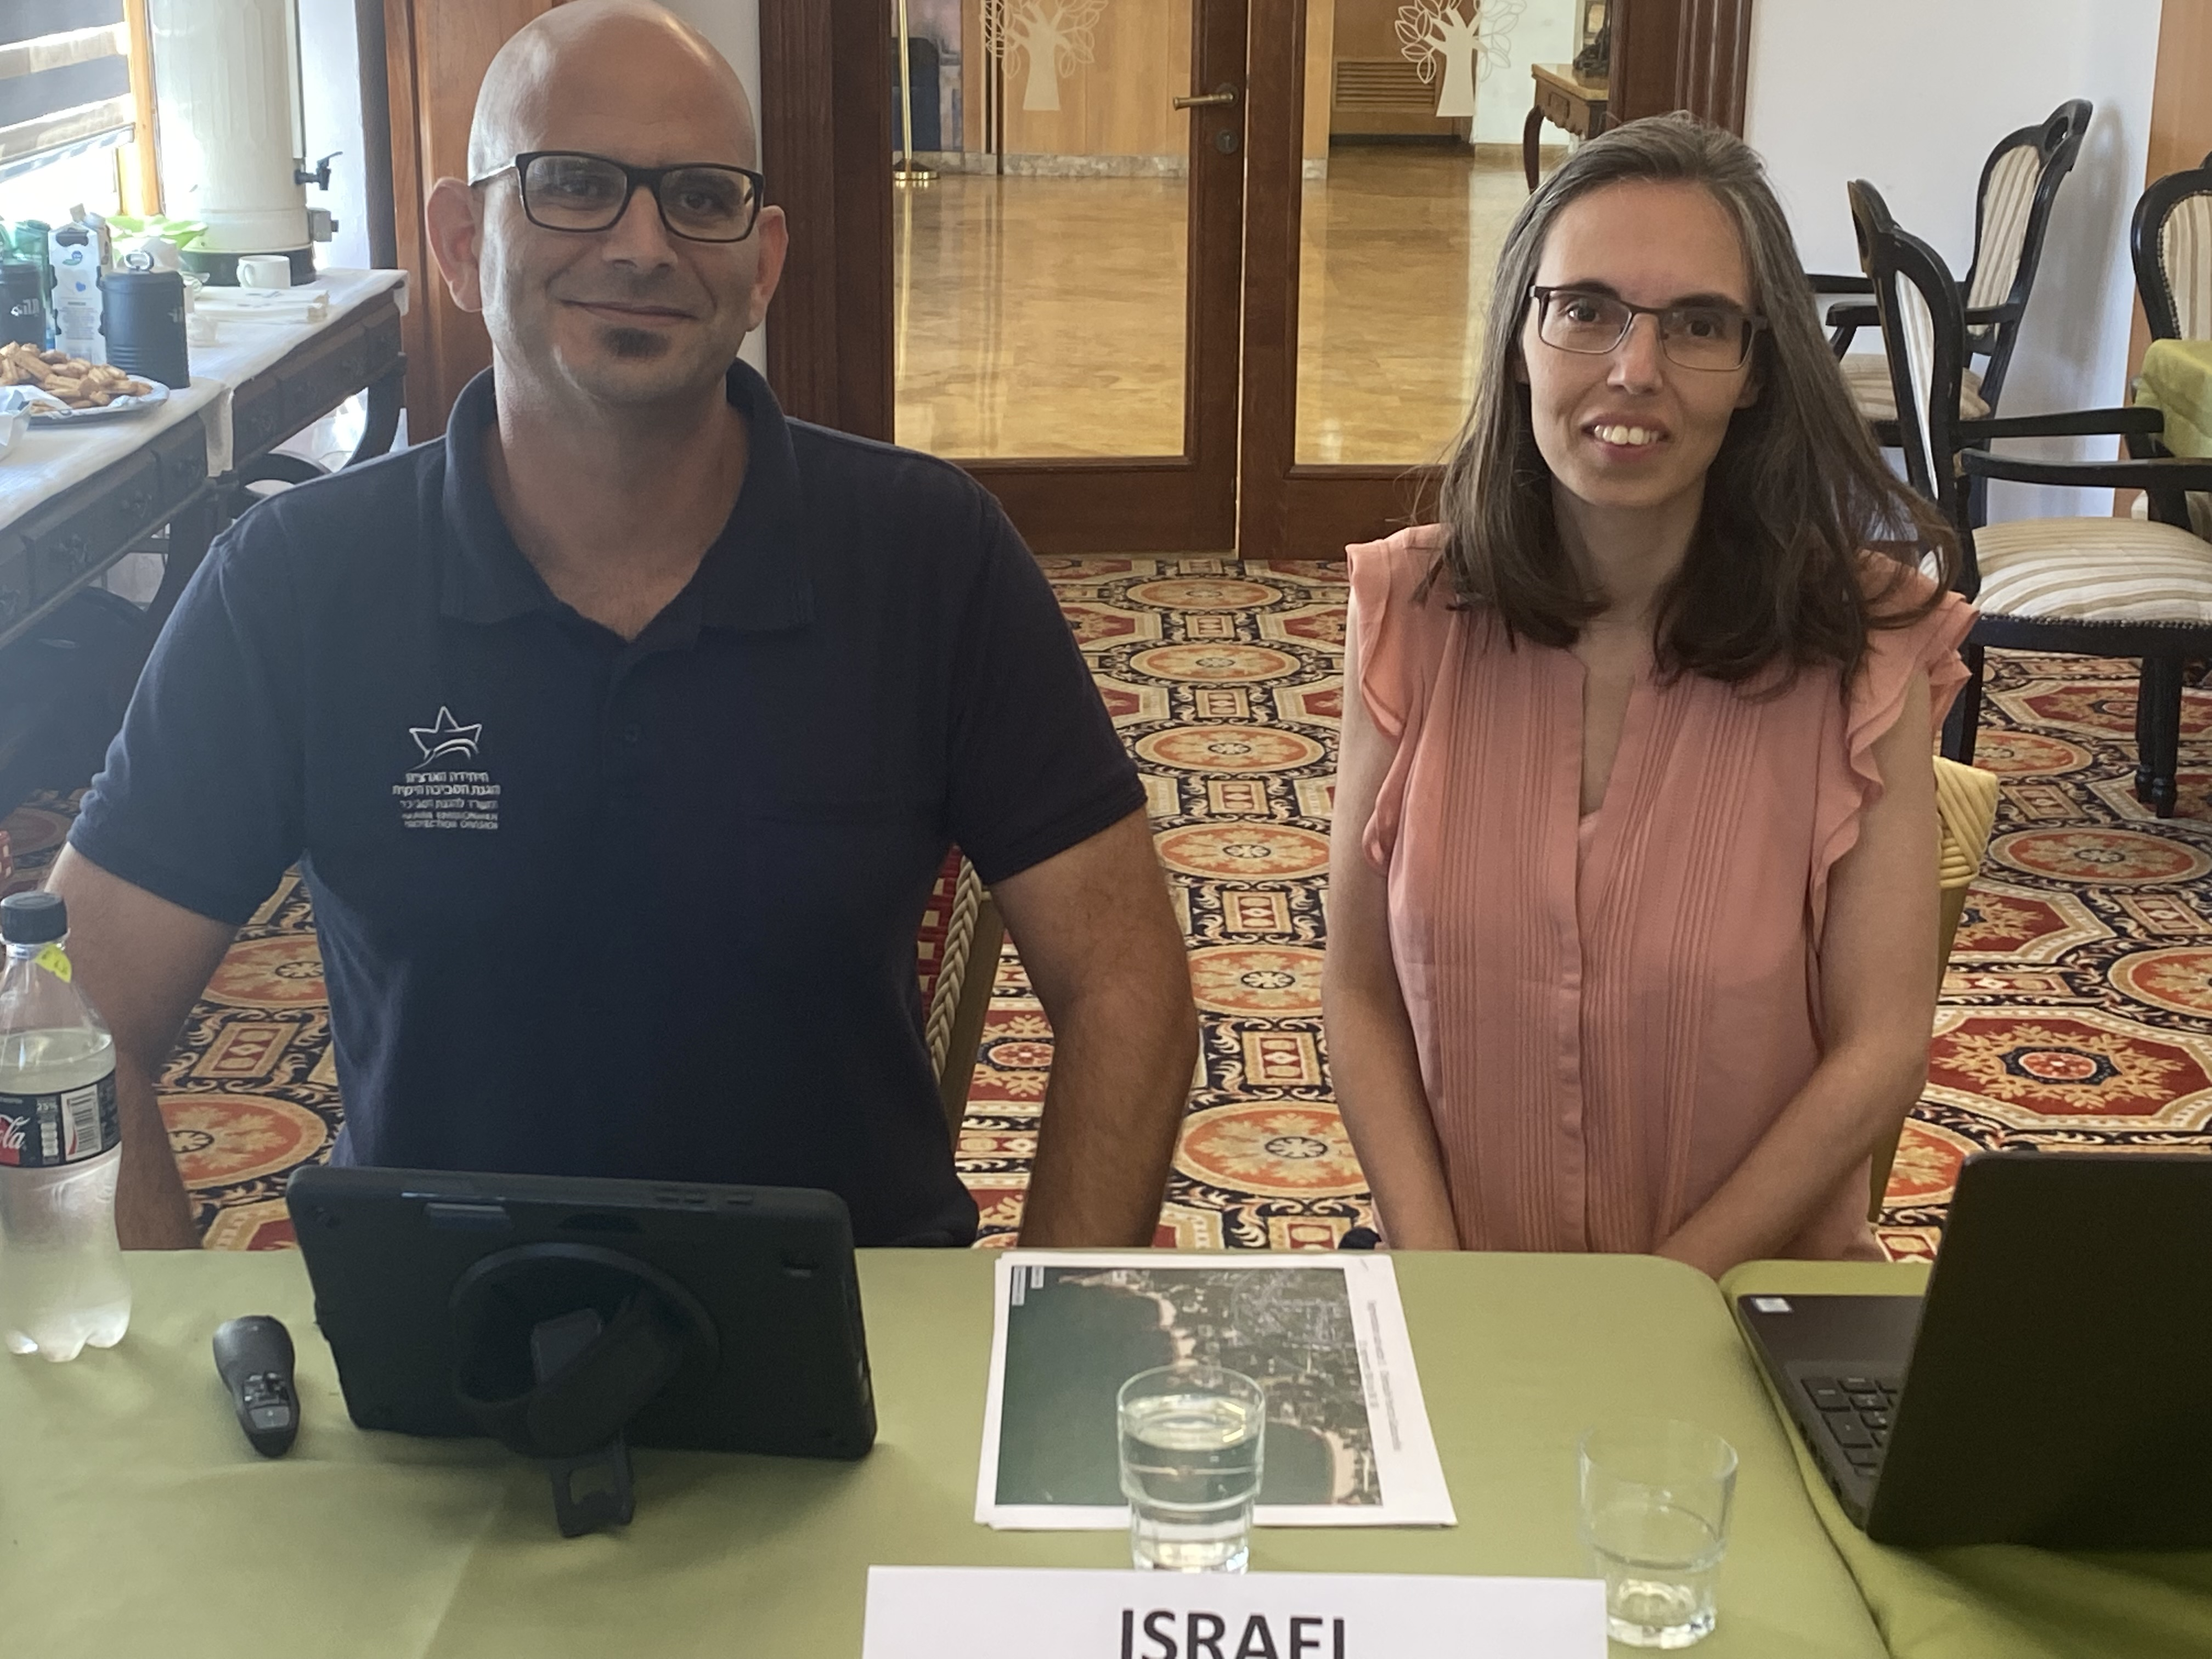 | 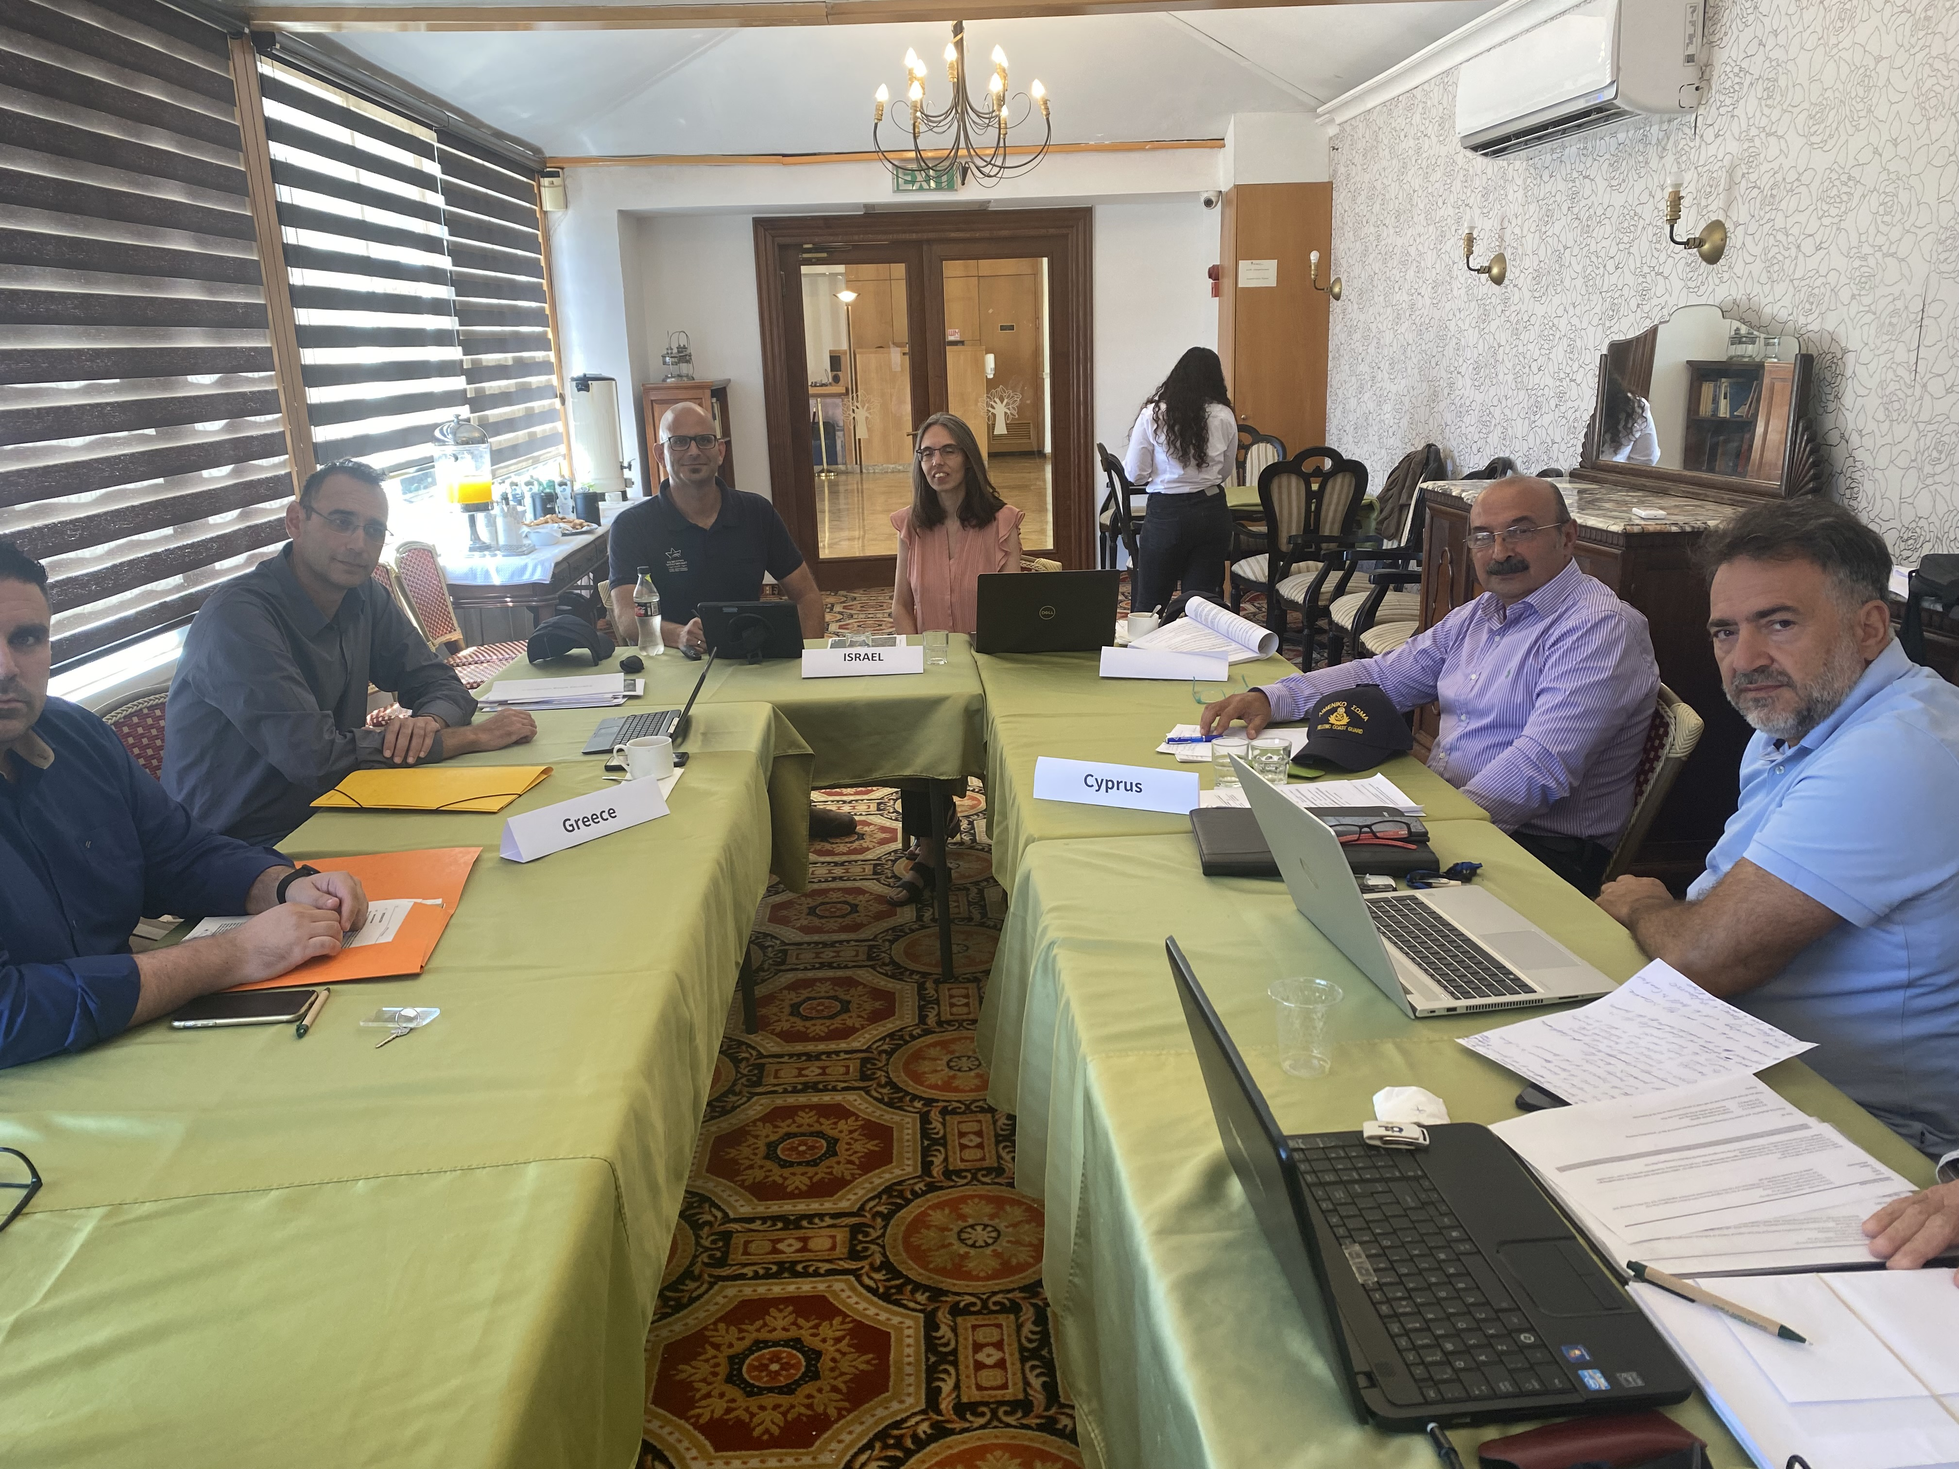

Report of the meeting provided in the document REMPEC/CGI SCP/WG.3/10, par. 52
Report of the meeting provided in document SCP CGI/PM.1/10, annex III
Report of the meeting provided in document SCP CGI/PM.2/9, par. 16
Report of the meeting provided in document SCP CGI/PM.2/9, par. 48
Report of the meeting provided in document SCP CGI/PM.2/9, par. 16
Report of the meeting provided in document SCP CGI/PM.2/9, par. 22
Report of the meeting provided in document SCP CGI/PM.2/9, par. 42
Report of the meeting provided in document SCP CGI/PM.2/9, par. 43
‘Mid-term activities provided in document SCP CGI/PM.1/7
Document REMPEC/WG.51/INF.4 of the 14th Meeting of the Focal Points of REMPEC,

